**DIGITAL CIRCUITS LABORATORY**

**Experiment-7**

**Full Adder using VHDL and CPLD Board**

Tanish H Talapaneni

200020050

**Aim:**To implement the Full Adder by writing the code using VHDL and implementing it on the CPLD Board

**Summary:** Implementation of the Full Adder on CPLD board by wiring up the circuit and executing the 3 types of VHDL code

**Components used:**CPLD Board, PC

**Procedure:**

* Configure the Quartus Software and open a new project
* Writing the code for Full Adder in VHDL
* Compiling the code and correcting all errors
* Viewing the RTL schematic of the written VHDL Code
* Creating .svf file and planning the pins for outputs and inputs, in order to execute on the CPLD Board
* Running the code on the CPLD Board by executing it via the Terminal Window on the PC

**VHDL Code:**

i)VHDL Code for Full-Adder in Dataflow modeling style:

-- Data flow modeling:

library ieee;

use ieee.std_logic_1164.all;

-- Data Flow Modelling Style

entity full_adder_dataflow is

port(a, b, cin: in bit;

sum, cout: out bit);

end full_adder;

architecture dataflow of full_adder_dataflow is

begin sum <= a xor b xor cin;

cout<= (a and b) or ((a xor b) and cin);

end dataflow;

ii)VHDL Code for Full-Adder in Behavioral Modeling Style:

-- Behavioral modeling Style:

library ieee;

use ieee.std_logic_1164.all;

entity full_adder_behaviroal is

port (a, b, cin: in std_logic; s, cout: out std_logic);

end full_adderb;

architecture behavior of full_adder_behaviroal is

Begin

c1: process (a,b,cin) Begin

if a = ‘0’ and b = ’0’ then

s <= cin;

cout <= 0;

if a = ‘0’ and b = ‘1’ then

s <= not cin;

c <= cin;

if a = ‘1’ and b = ‘0’ then

s <= not cin;

cout <= cin;

if a = ‘1’ and b = ‘1’ then

s <= cin;

cout <= 1;

end if;

end process c1;

end behavior;

iii)VHDL Code for Full-Adder in Structural Modeling Style:

-- structural Full Adder

library ieee;

use ieee.std_logic_1164.all;

entity FAS is

port (A, B,Cin: in std_logic;

S, Cout: out std_logic);

end FAS;

architecture structure of FAS is

signal o1, o2, o3, o4, i1, i2, i3, i4, i5,i6,i7,i8,i9,i10,i11: std_logic;

-- gates description

component xor_gate_3

port (i1, i2,i3: in std_logic;

o1: out std_logic);

end component;

component xor_gate_2

port (i4,i5: in std_logic; C

o2: out std_logic);

end component;

component and_gate_1

port (i6,i7: in std_logic;

o3: out std_logic);

end component;C

component and_gate_2

port (i8, i9: in std_logic;

o4: out std_logic);

end component;

component or_gate

port (i10, i11: in std_logic;

o5: out std_logic);

end component;

begin

u1: xor_gate_3 port map (i1 => A, i2 => B, i3 => Cin, o1 => i4);

u2: xor_gate_2 port map (i4 => o1, i5 => Cin, o2 => S);

u3: and_gate_1 port map (i6 => o1, i7 => Cin, o3 => i10);

u4: and_gate_2 port map (i8 => A, i9 => B, o4 => i11);

u5: or_gate port map (i10 => o3, i11 => o4, o5 => Cout);

end structure;

library ieee;C

use ieee.std_logic_1164.all;

entity xor_gate_2 is

port (i4, i5: in std_logic;

o2: out std_logic);

end xor_gate_2;

architecture dataflow of xor_gate_2 is

BeginC

o2 <= i4 xor i5;

end dataflow;

library ieee;

use ieee.std_logic_1164.all;

entity xor_gate_3 is

port (i1, i2,i3: in std_logic;

o1: out std_logic);

end xor_gate_3;

architecture dataflow of xor_gate_3 is

Begin

o1 <= ((i1 xor i2) xor i3);

end dataflow;

library ieee;

use ieee.std_logic_1164.all;

entity and_gate_1 is

port (i6, i7: in std_logic;

o3: out std_logic);

end and_gate_1;

architecture dataflow of and_gate_1 is

Begin

o3 <= i6 and i7;

end dataflow;

library ieee;

use ieee.std_logic_1164.all;

entity and_gate_2 is

port (i8, i9: in std_logic;

o4: out std_logic);

end and_gate_2;

architecture dataflow of and_gate_2 is

Begin

o4 <= i8 and i9;

end dataflow;

library ieee;

use ieee.std_logic_1164.all;

entity or_gate is

port (i10, i11: in std_logic;

o5: out std_logic);

end or_gate;

architecture dataflow of or_gate is

Begin

o5 <= i10 or i11;

end dataflow;

**Hardware:**

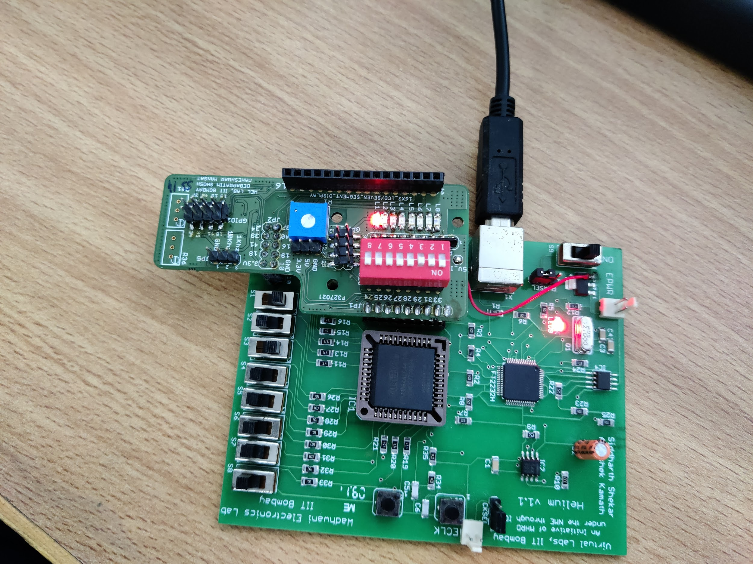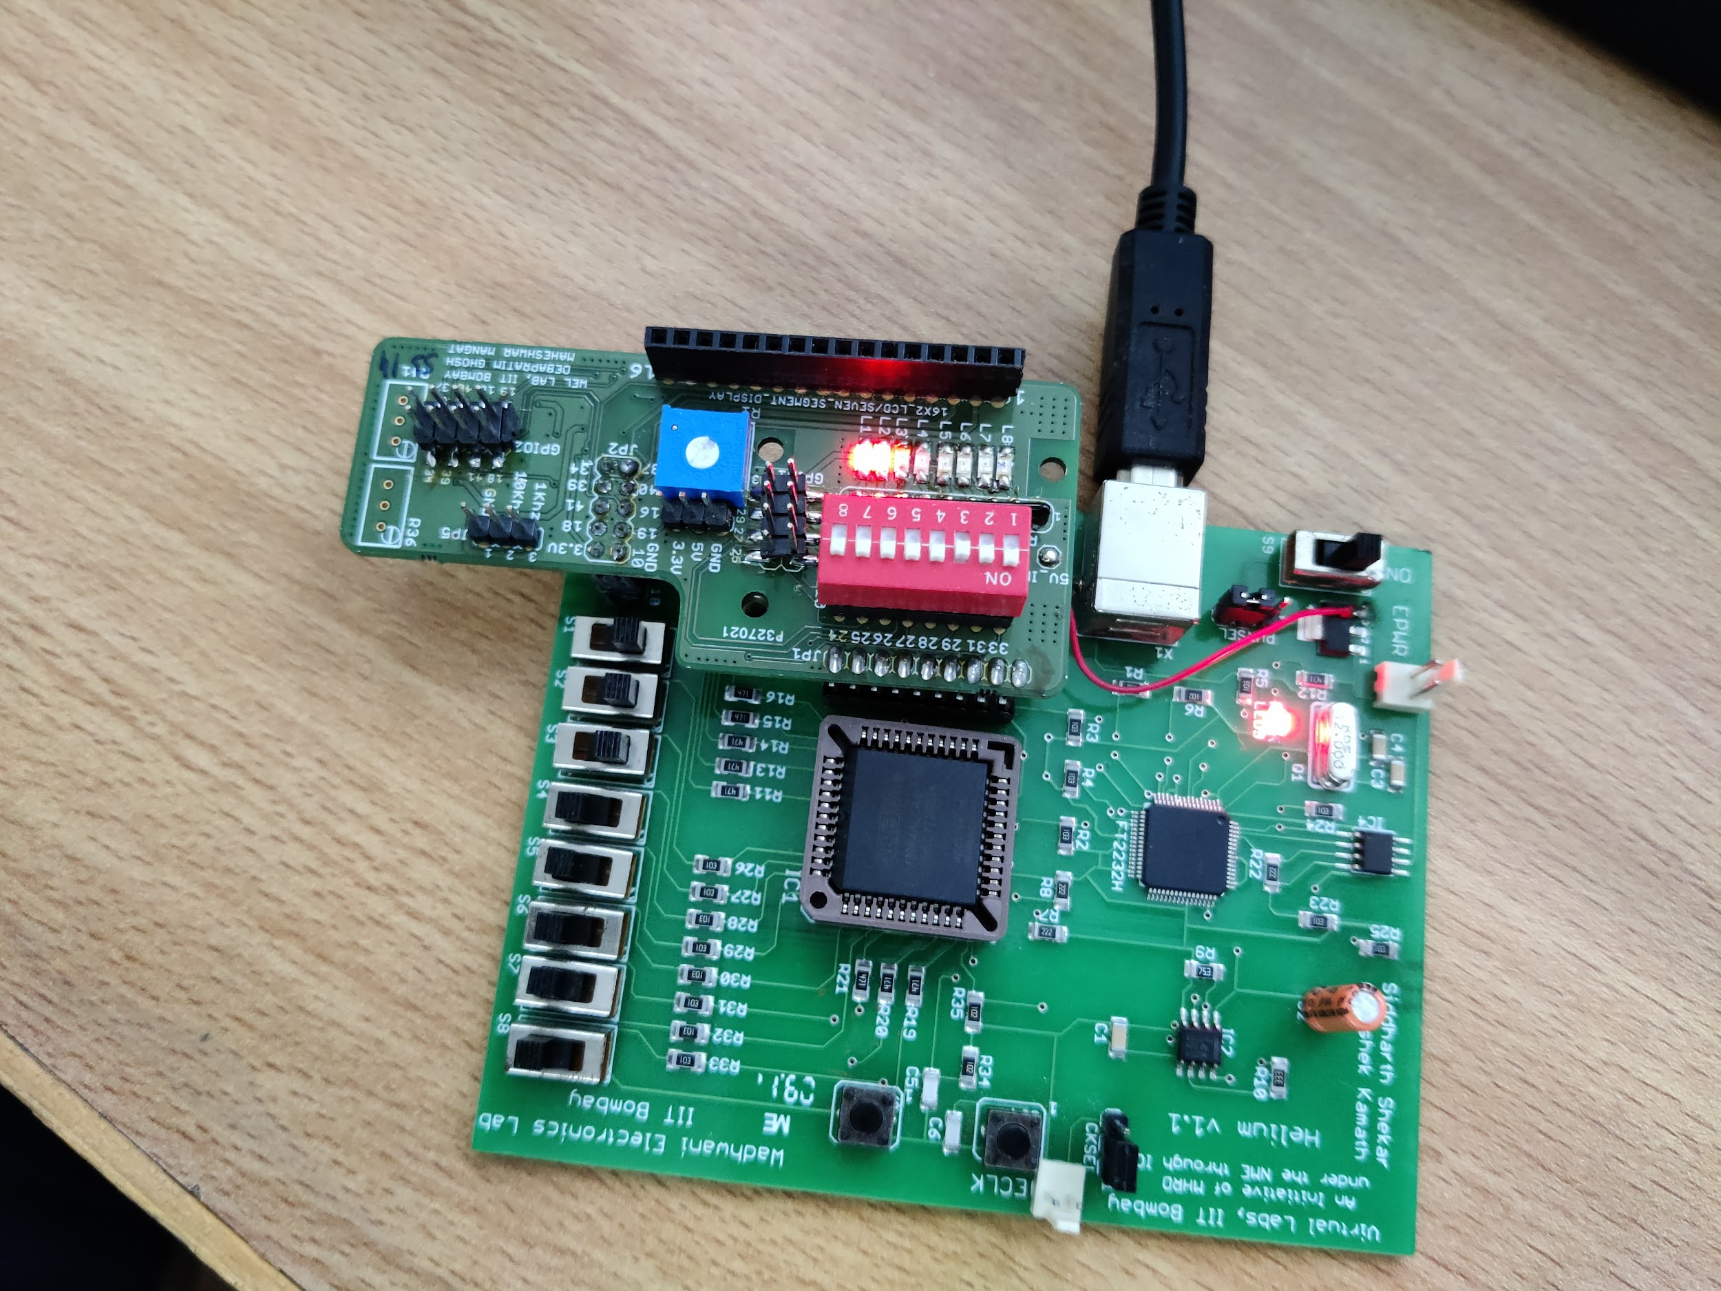

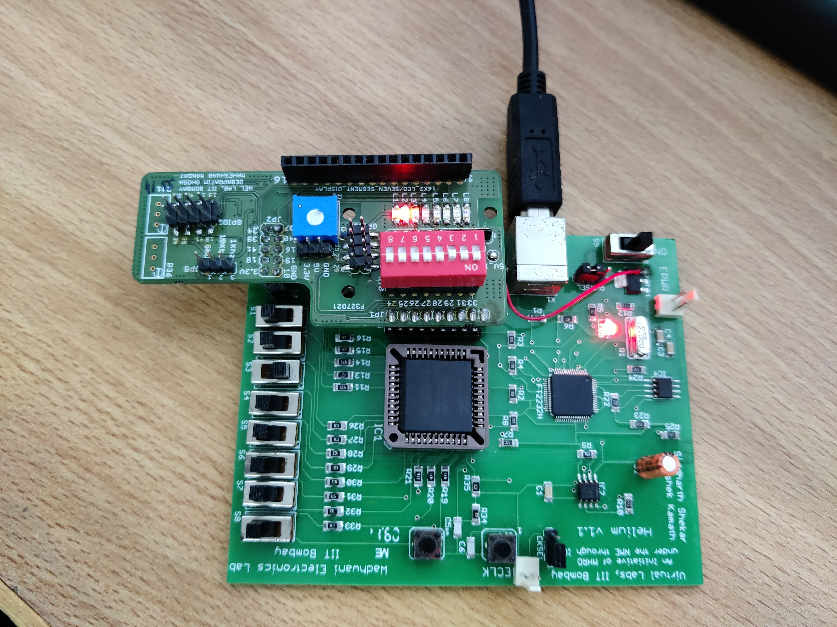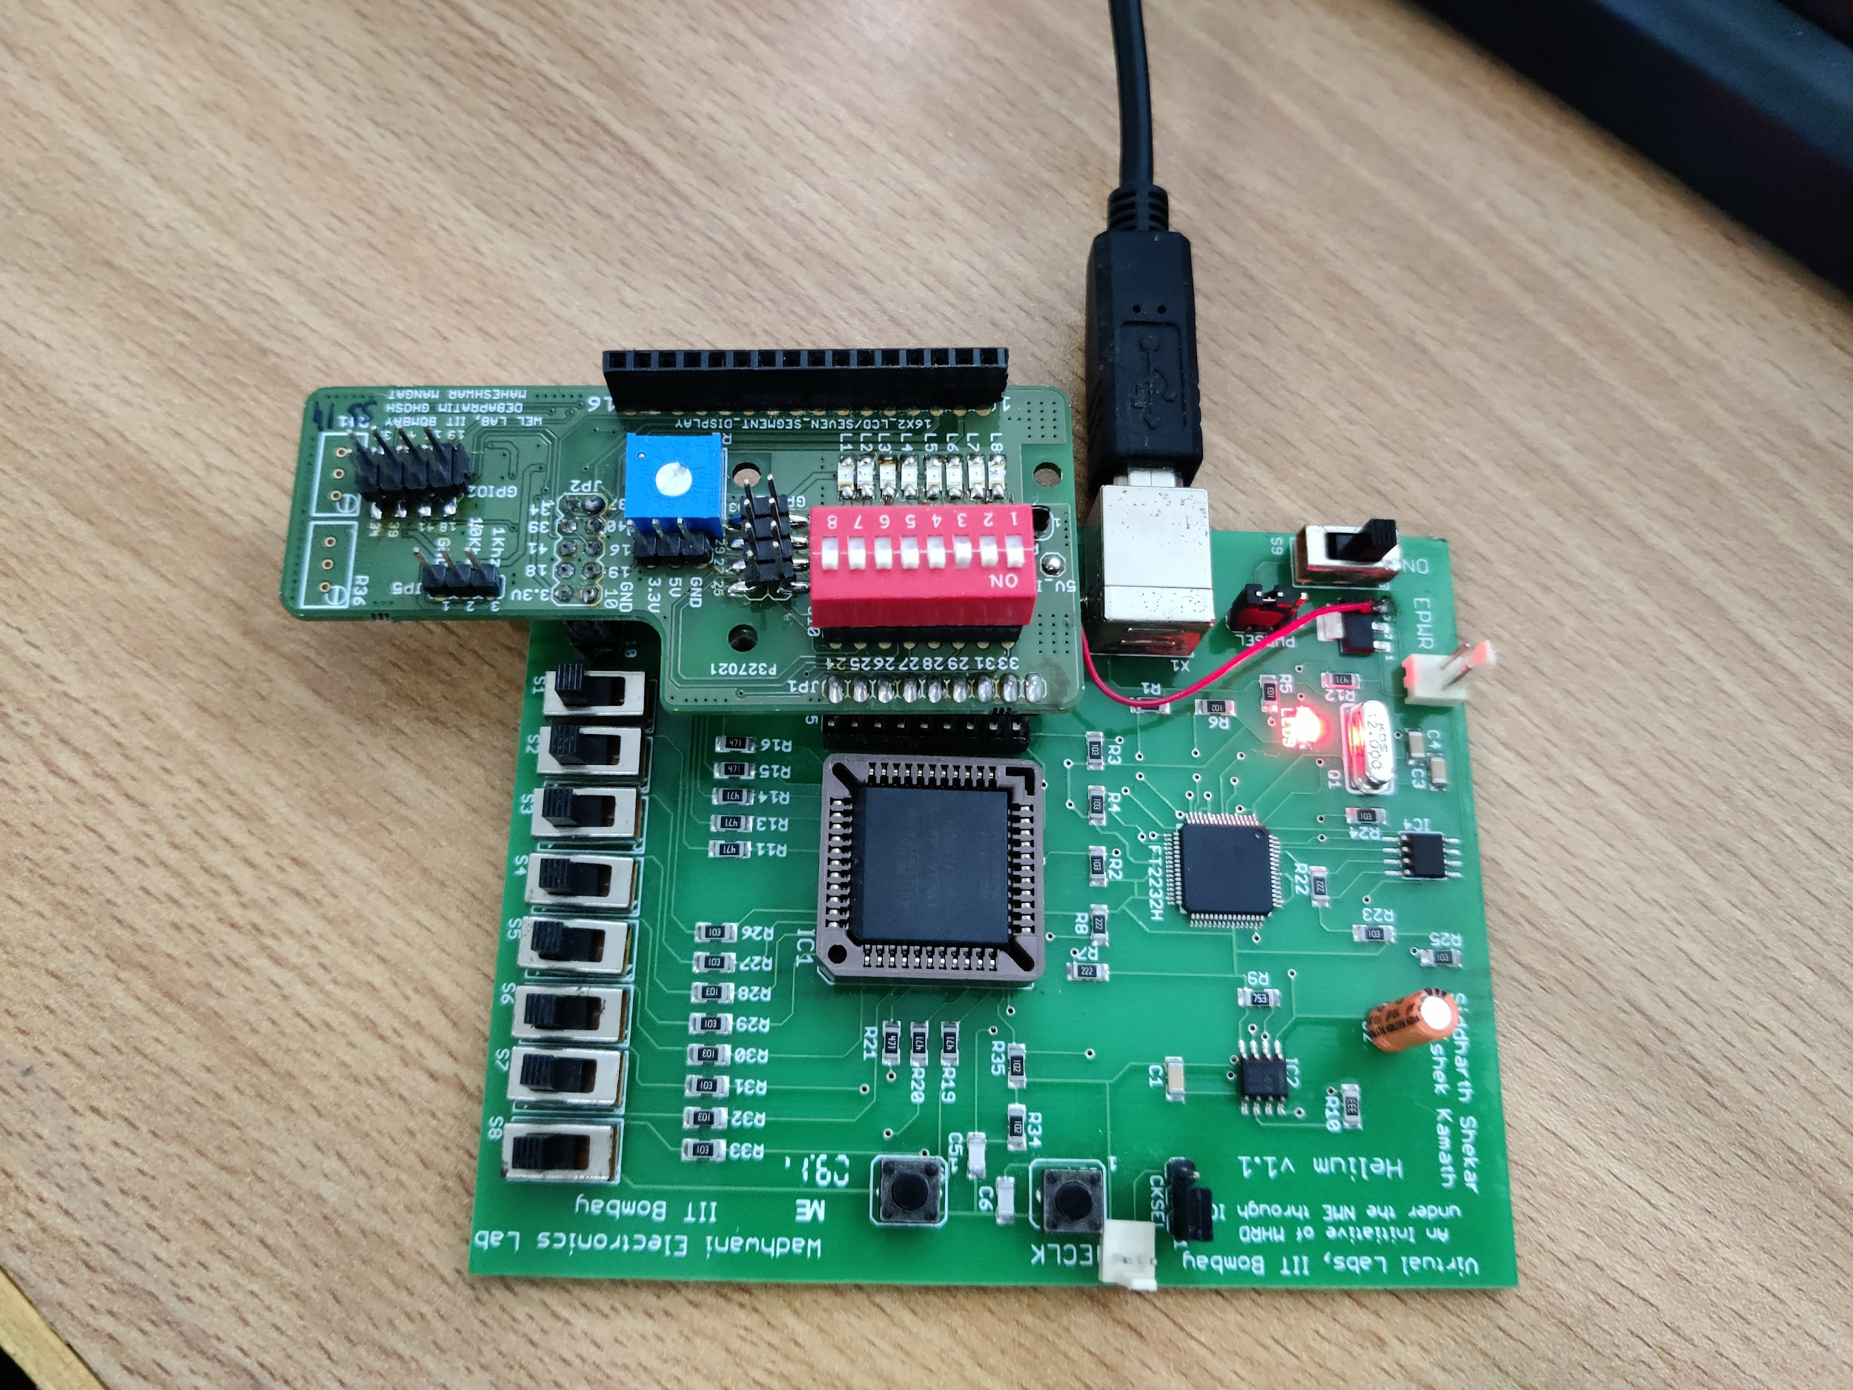

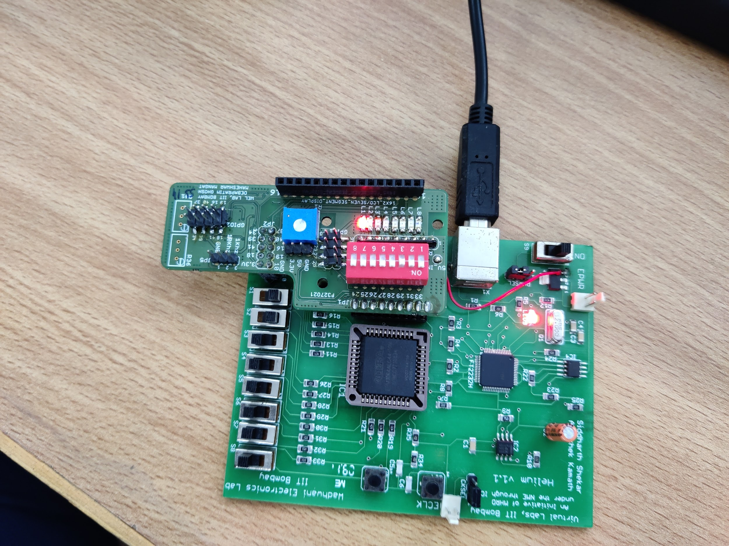

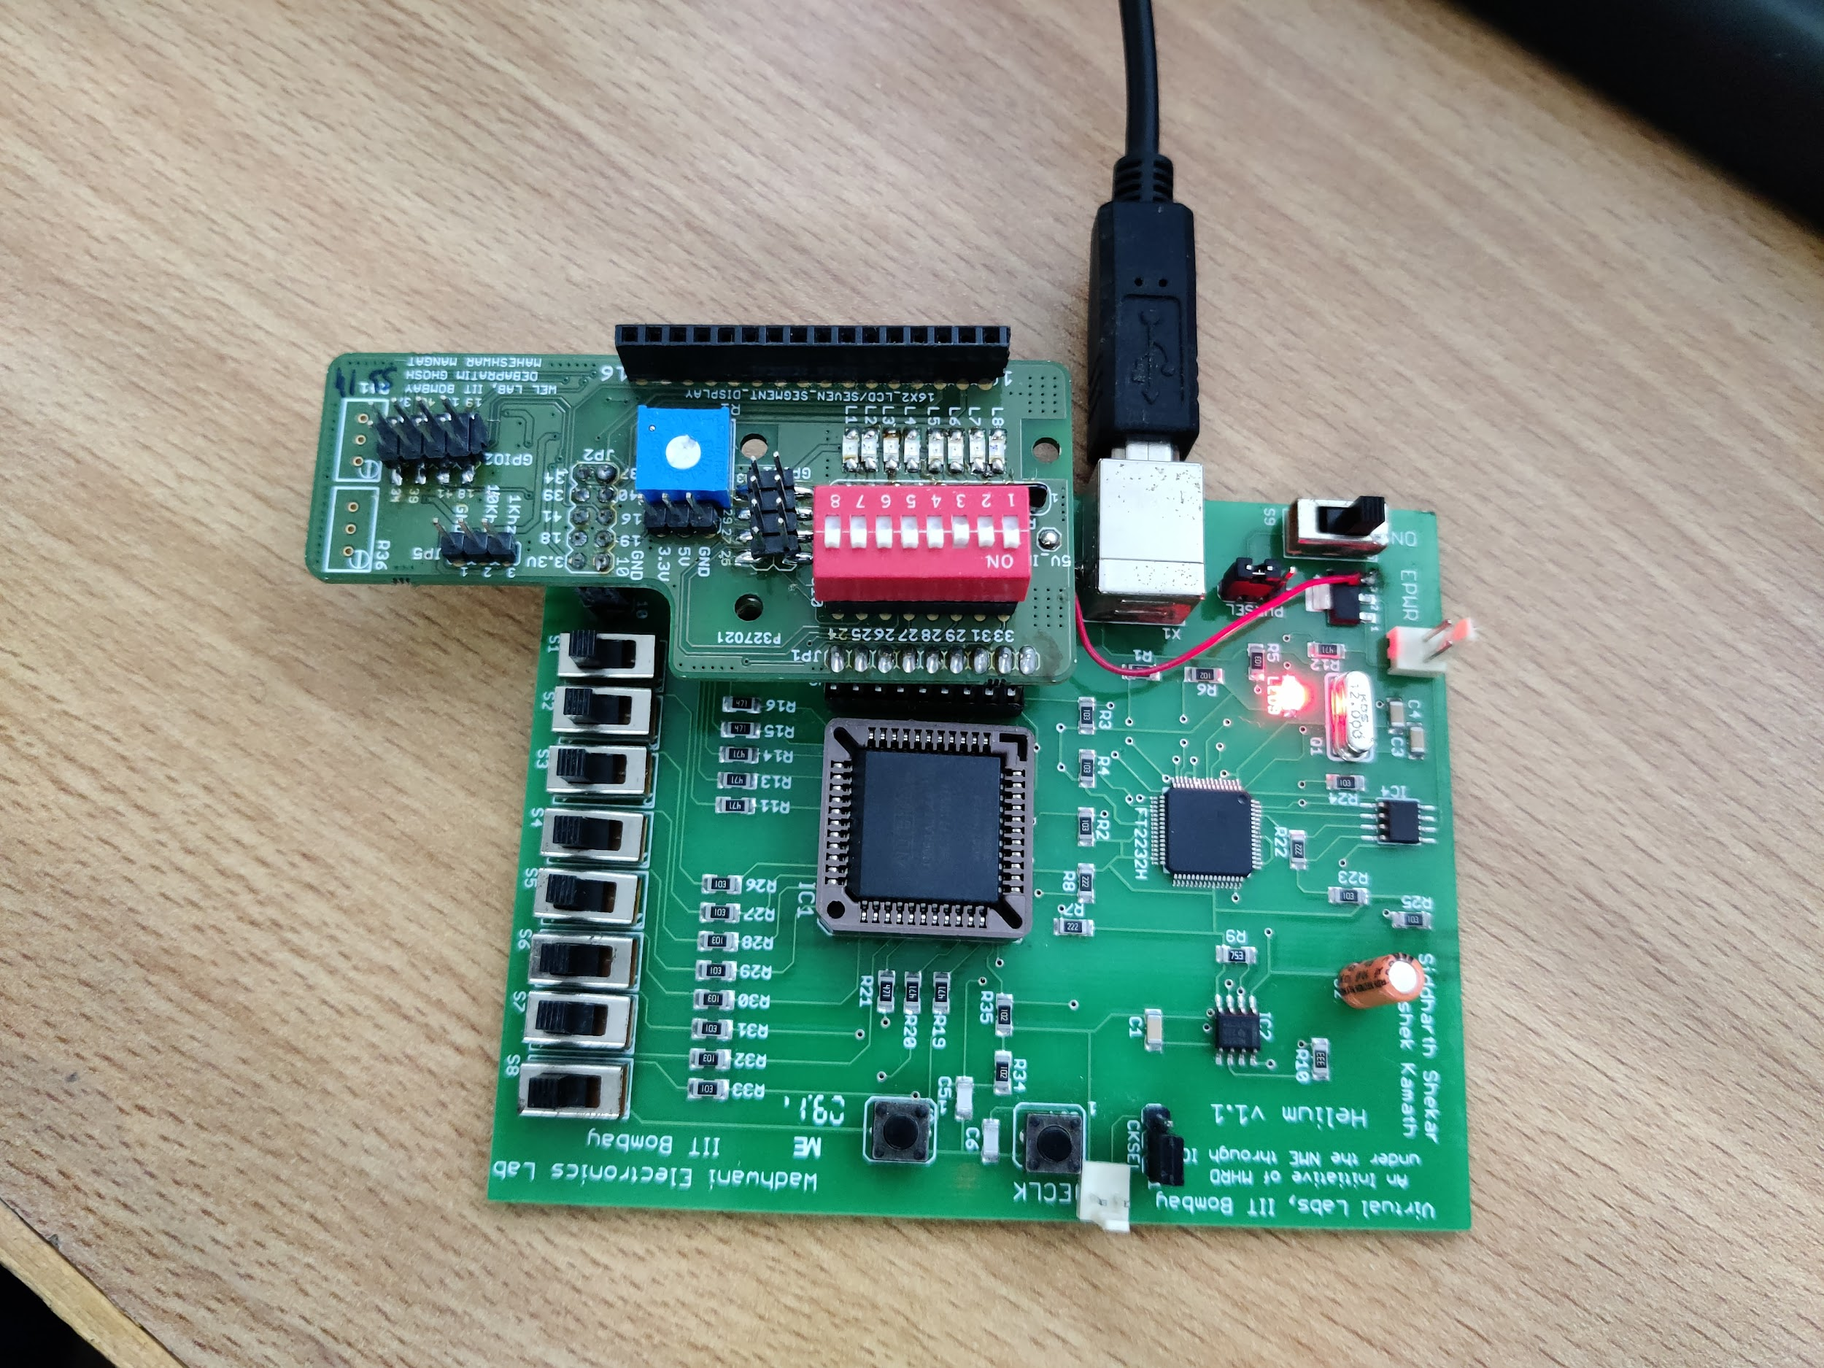

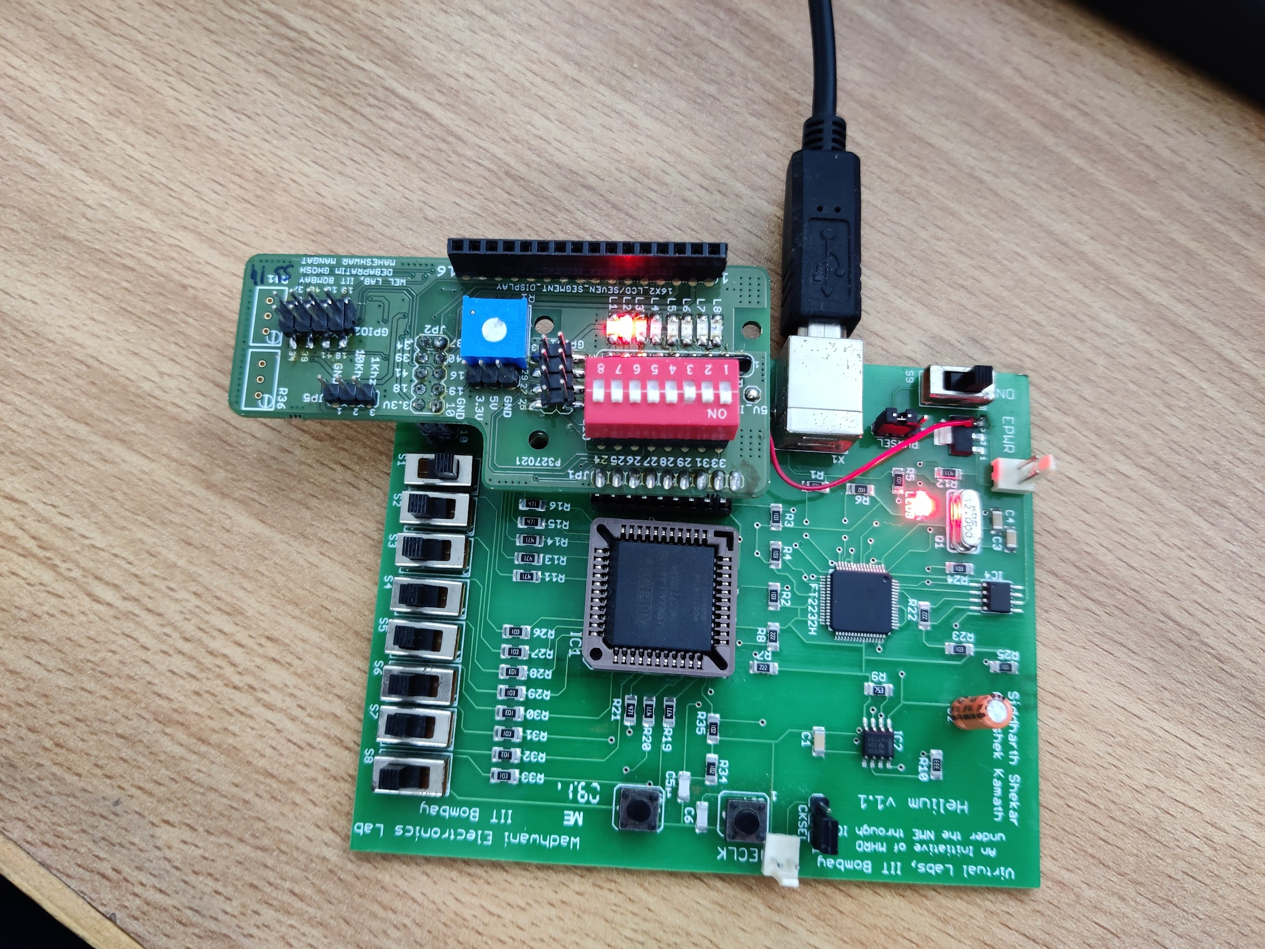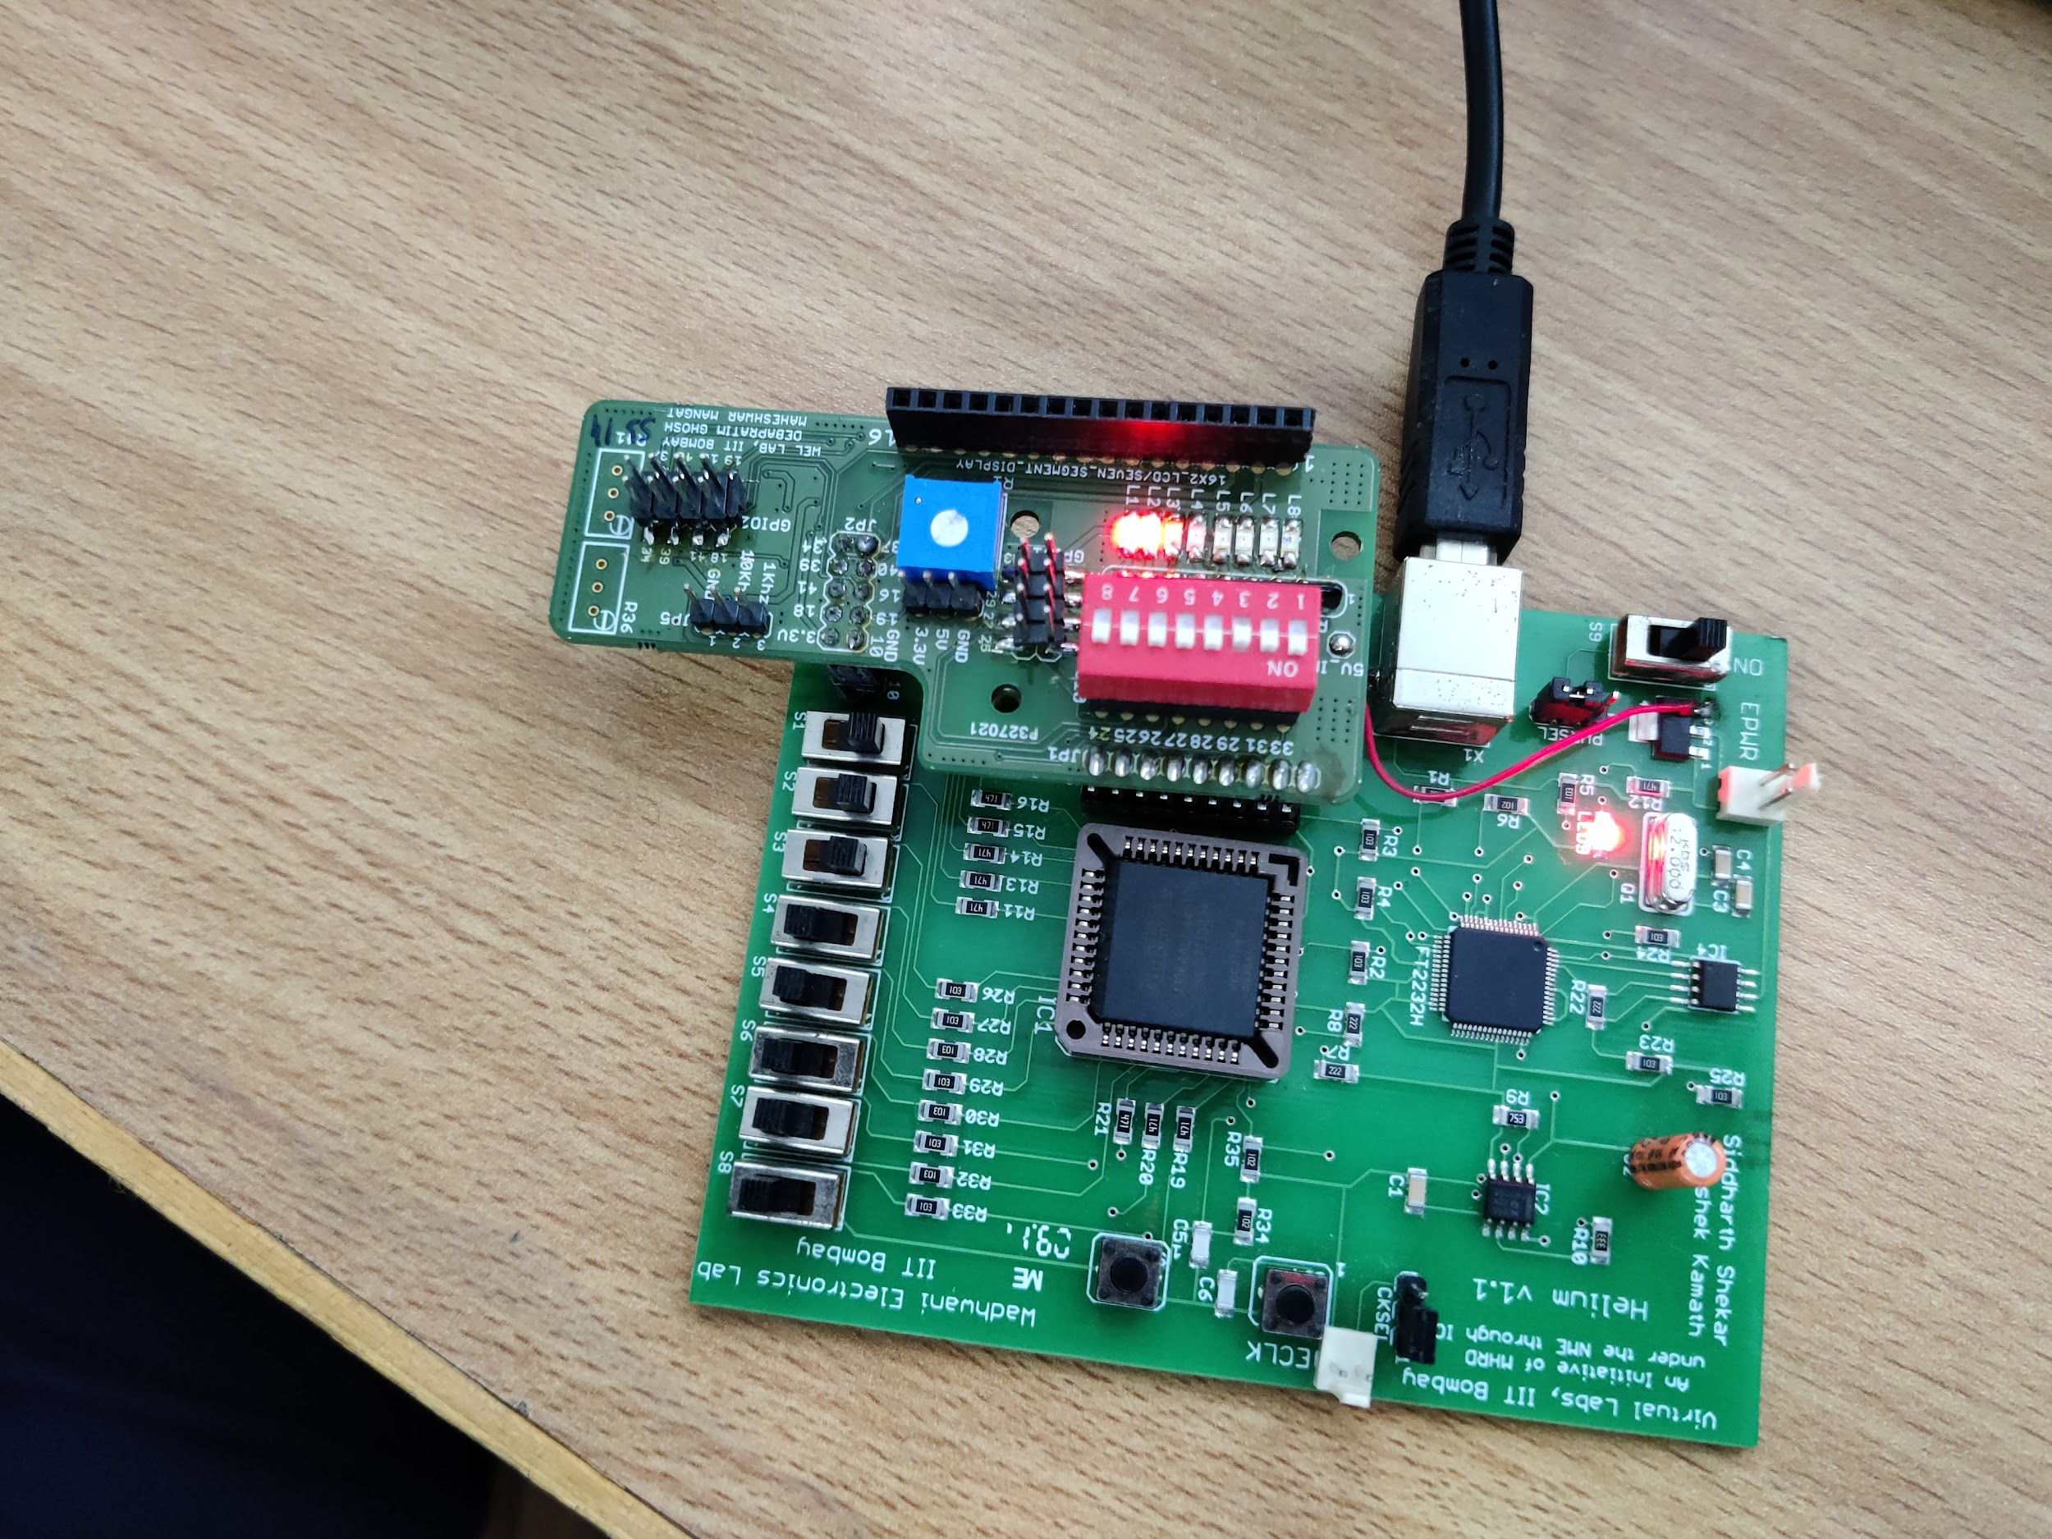

**Results and Discussions:** We finally understood how to program in VHDL and how to use the CPLD Board and execute the working of many devices which we will learn in the future. Initially, it was tricky to configure the software and write the codes, as it was our first time, but slowly we learnt and corrected all of the errors, and we were finally able to see the output of the full adder on the CPLD Board. We coded the working of the Full Adder in 3 modes: Data Flow, Behavioral and Structural, and it was nice to analyze the differences observed in the working of the three codes. Overall, it was a great experience working with VHDL and CPLD.

**Conclusion:**

Execution of Full-Adder Logic on the CPLD Board using VHDL Programming Language. Three types of logic were used: Data Flow, Behavioral and Structural. Data Flow Logic is based on the type of input(0 or 1). Behavioral Logic is based on if-else statements applied on the inputs. Structural Logic is based on designing the structure of each logic gate involved. The output observed is the same for all three types of design, as all the designs encode the same logic of the Full Adder.